# Final Project Part 1 (Assignment 3)

## Project Description

This project is a homework assignment to teach how to use Pycharm with Docker, Flask, MySQL, Jinja, Bootstrap, and Postman. Postman screenshots are here.

## Postman listing all records

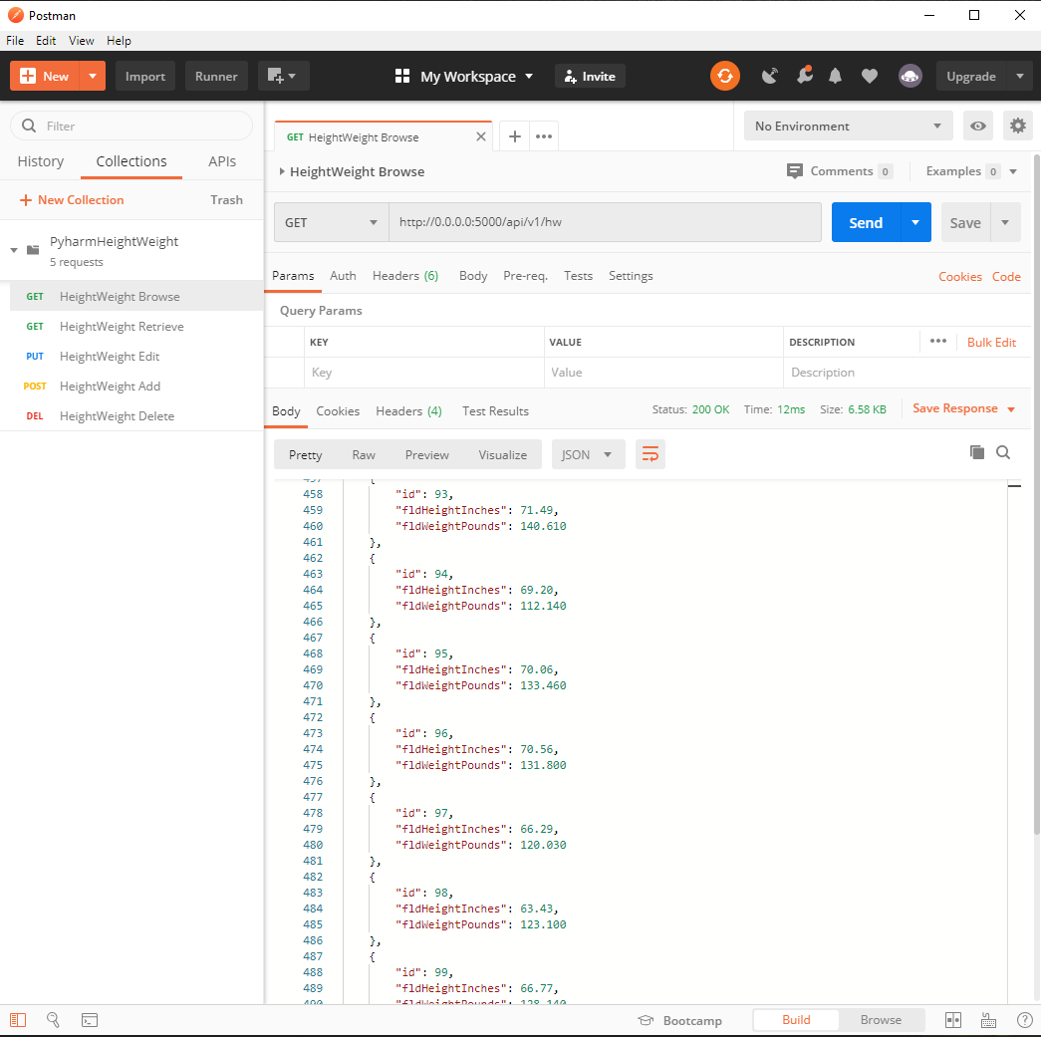

## Postman showing one record with get request

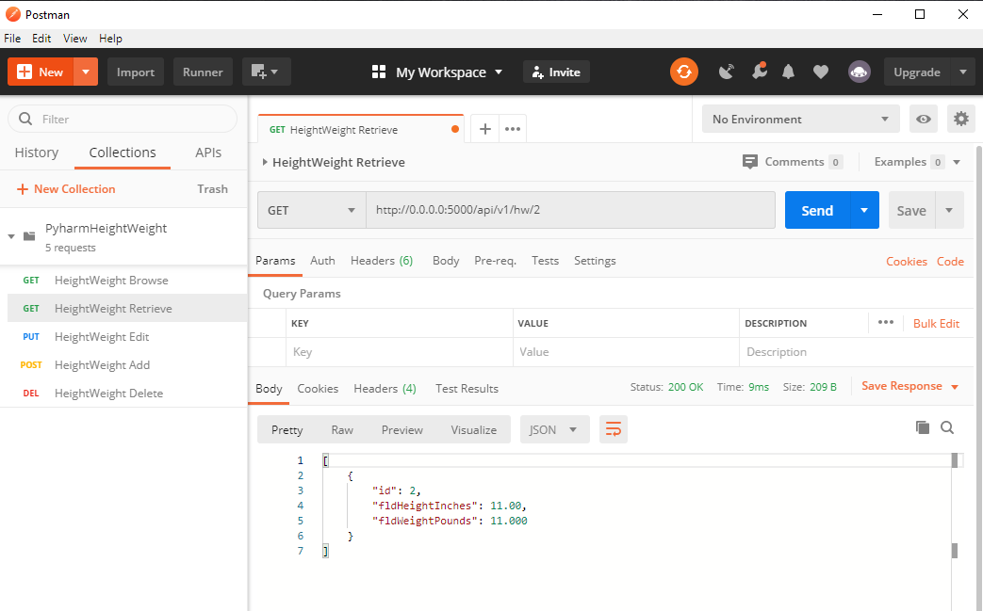

## Postman showing create record and result

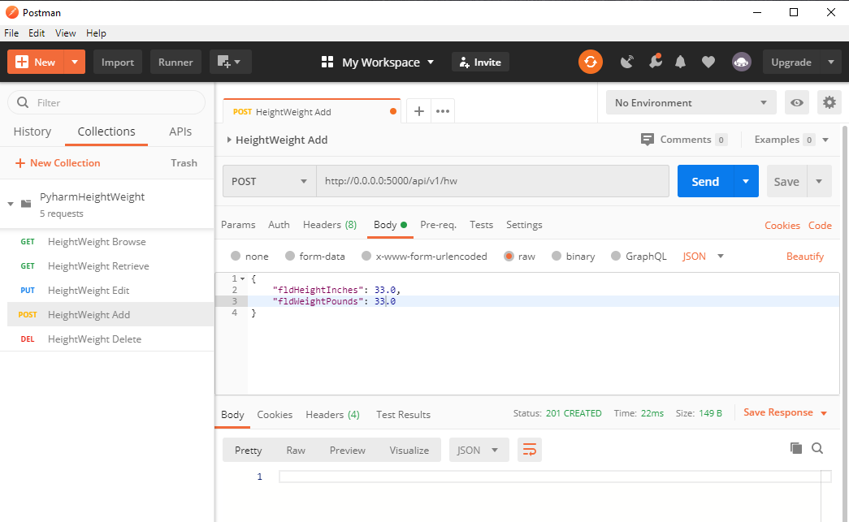

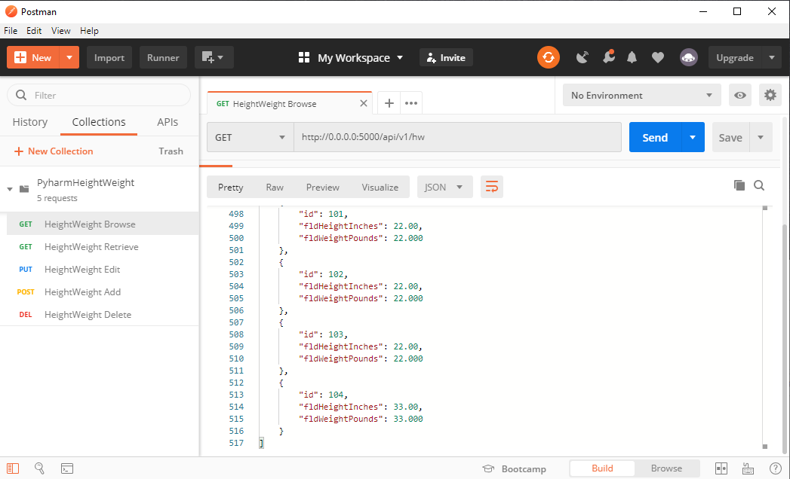

## Postman showing edit record and result

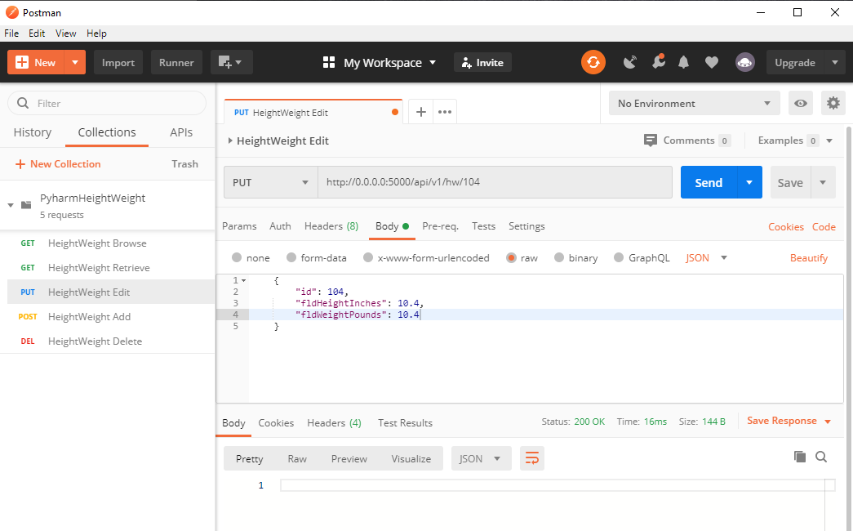

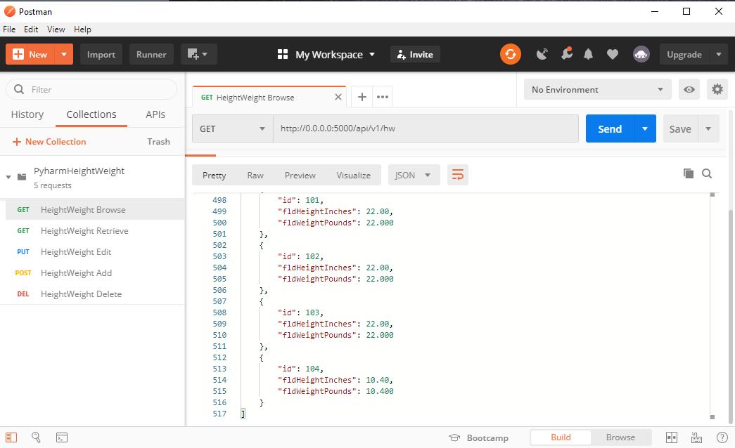

## Postman showing delete record and result

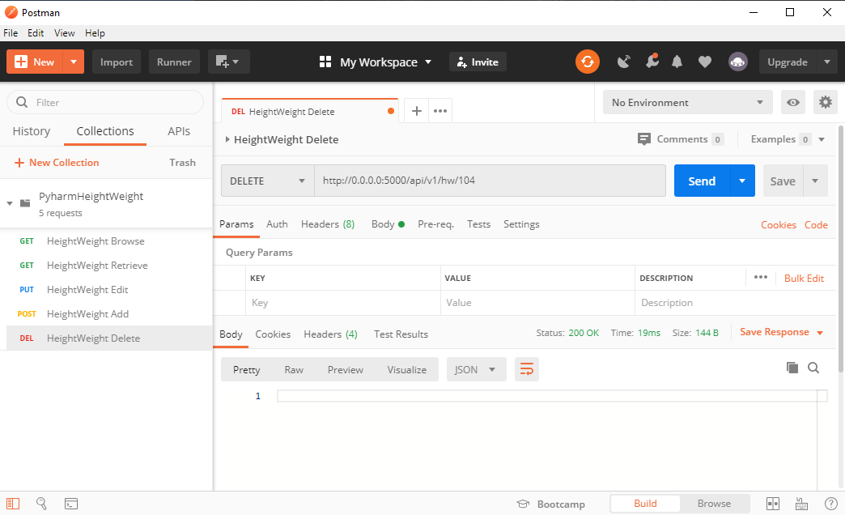

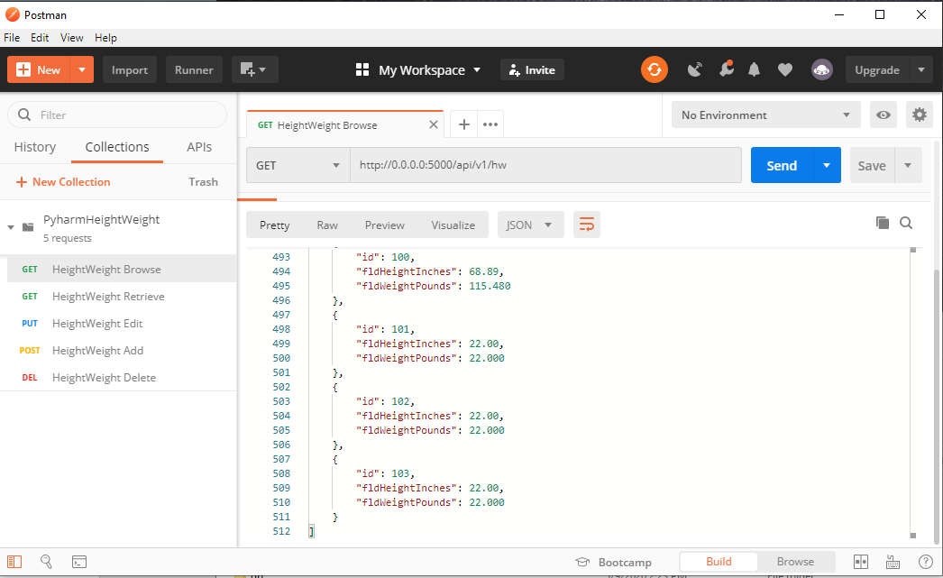

## Author

Scott Grodberg

## Changelog

* 5/9/20 Initial commit
* 5/10/20 Fixup REST endpoints to use my data
* 5/10/20 Update readme and Word Doc.